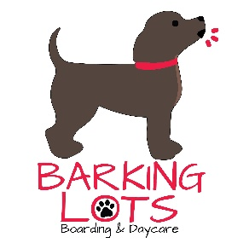

Application

Owner name: _______________________________________ Cell: _______________________

Co-Owner name: ____________________________________ Cell: _______________________

Address: ____________________________________ City: ________________ Zip: __________

Home phone: ______________________ Email: ______________________________________

Emergency contact: _________________________________ Phone: ______________________

Who else do you authorize to drop off or pick up your pet? _____________________________

______________________________________________________________________________

Pets name: ________________________________ DOB/age____________________________

Breed: _______________________ Color: _______________________ Weight: _____________

Male or Female Spayed / Neutered / NOT spayed or neutered

All pets participating in group play must be altered by 6 months of age

Flea prevention used: ___________________________ Last date given: ___________________
Note: if our staff finds any evidence of fleas or ticks, your pet will be treated at your expense

Veterinarian name: ______________________________________________________________

Clinic name: _________________________________Phone: ____________________________

*Proof of vaccinations are required from Veterinarian and must be up to date

Rabies expiration: ________________ DA2PL expiration: __________________

Bordetella expiration: __________________
* Nasal or oral Bordetella is required every 6 months and must be given at least 2 days prior to check in (7 days prior if injectable)

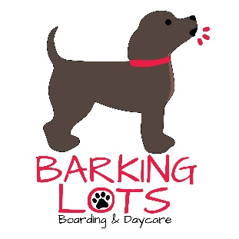

Medical History

Is your pet currently taking any medications? Yes _________ No _________
Note: if you answered yes, please complete a medication administration form

Has your pet been ill in the last 30 days? Yes __________ No ____________

Is your pet displaying any symptoms such as coughing, sneezing, or upset stomach?
Yes ___________ No _____________

Does your pet have any allergies to anything?
Yes ___________ No _____________

If yes, please list: ________________________________________________________________

Does your pet have any previous or current injuries, physical disabilities, or health concerns we need to be aware of? Yes ______________ No ______________

If yes, please explain: ____________________________________________________________

Does your pet have any physical restrictions while playing or any sensitive areas on the body?
Yes ___________ No ______________

If yes, please explain: ____________________________________________________________

Are there any restrictions that we need to place on your pet? Yes __________ No __________
Ex.: no jumping, no running, no rough play, no contact with other dogs

If yes, please explain: ____________________________________________________________

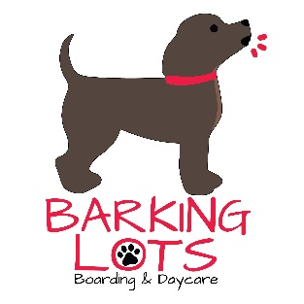

Medical Care Release

This form is required for all of our daycare and overnight boarding guests. The welfare and safety of your dog is of utmost importance. If a medical emergency should arise while your dog is attending daycare or being boarded at our facility, it is critical that we are able to provide medical treatment quickly.

_______ I understand that medical concerns may arise while my pet is in the care of Barking Lots. I would like Barking Lots to seek veterinary care for my pet if there are ANY medical concerns. I understand I will incur additional charges and I agree to be responsible for any and all charges as deemed necessary by the Barking Lots staff and the veterinarian providing the services.
_______ No limit on amount of medical care provided to my pet
_______ I request a limit of $_______ to be spent on medical care for my pet
_______ I would like Barking Lots to attempt to contact me prior to seeking medical care.
I can be reached at ____________________. If I can’t be reached, I authorize ______________________________ to make decisions regarding my dog. He/she can be reached at ____________________________________________________.
_______ If I and/or my emergency contact can’t be reached, I would like Barking Lots to seek medical treatment they feel is necessary.
_______ I do NOT want Barking Lots to seek veterinary care for my dog under any circumstance, even if it is believed to be life threatening.
My signature below authorizes Barking Lots staff to seek medical care as selected above. I agree to pay the veterinary hospital the charges incurred (based on my selection). I further understand that my pet will be transported in a staff vehicle to the nearest available veterinarian hospital

Owner: | Date:

