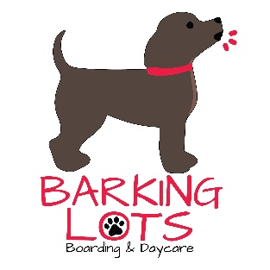

Personality Profile

Pet’s name: _________________________ Owner: _________________________

1. Where did you get your dog from?
□ breeder □ rescue / shelter □ found

2. How long has your dog lived with you? _________________________________

3. Is your dog the only dog in the home? □ yes □ no
If no, how many and how do the dogs typically get along with each other?

___________________________________________________________________

4. How does your dog react to meeting new dogs?

___________________________________________________________________

5. If you ever have visitors bring their dogs to your home, how does your dog get along with them?

___________________________________________________________________

6. How does your dog react to a stranger coming into your home or yard?

___________________________________________________________________

7. Is your dog afraid of thunder, fireworks, or any other loud noises? □ yes □ no

8. Any particular people your dog is afraid of? _____________________________
□ men □ women □ children

9. Has your dog ever been in boarding or open play groups with other dogs?
□ yes □ no
If yes, please explain how they did. ______________________________________

10. Check all that apply to your dog:

□ is crate trained □ housebroken □ walks well on a leash □ pulls on a leash
□ jumps up on people □ barks excessively □ escaped a crate or door
□ climbs or jumps fences □ eaten stool or foreign objects □ digs or chews

Please explain any issues above: ________________________________________

11. Has your dog ever growled at a person for any reason? □ yes □ no

If yes, please explain: _________________________________________________

12. Has your dog ever nipped or bitten a person? □ yes □ no

If yes, please explain: ________________________________________________

13. Has your dog ever bitten another dog? □ yes □ no

If yes, please explain: _________________________________________________

14. Is your dog possessive or territorial over toys, treats, or people? □ yes □ no

If yes, please explain: _________________________________________________

Owner: _________________________________ Date: _____________________

